Curriculum Vitae Vahid Rashidli

|  |  |
| --- | --- |
| PERSONAL INFORMATION | Vahid Rashidli |
|  | Koroglu Rahimov 57 a, Baku, Azerbaijan |
| +994 77 466 68 73 |
| [vrashidli1@gmail.com](mailto:vrashidli1@gmail.com) |
| Date of birth: 5 October 2001 Sex: Male |

|  |  |
| --- | --- |
| Summary |  |
|  | I am an easy going person who is always looking forward to communicating with a lot of people. Also, I am very passionate about my profession. I would say I am the kind of person who is always eager to learn and I will contribute tremendously to any team. Finally, you will benefit a lot from my presence and respectively, it will definitely play a significant role in shaping my career. |

|  |  |
| --- | --- |
| Work Experience |  |
| December 2020 –May  2021  June 2021- Current | Worked as a speaking teacher at CELT (Center for English Language Teaching) Colleges (Baku branch)  .NET developer at Devtrust (Ukrainian outsourcing company) |
| January 2022-Current | Backend developer at Kibrit |

|  |  |
| --- | --- |
| EDUCATION |  |

|  |  |
| --- | --- |
| September 2007 – May  2018 | Baku, MLK School |
| September 2018 – Current | Azerbaijan State Oil and Industry University, Faculty of Information  Technology, Mechatronic and Robotic Engineering |
| May 2020 – January 2021 | Code Academy, Web Development. |

|  |  |
| --- | --- |
| SKILLS |  |
| TECHNICAL | OOP, C#, ASP.Net MVC &Core, ASP.Net API development (+Core), WPF, SQL server, Postgres, Git, Github, EntityFrameWork, AJAX, Docker, Kubernetes, Azure Kubernetes Service, AWS SQS&SNS, Figma Design, HTML, CSS, BootStrap, Sass, JavaScript (native and JQuery) |
| OTHER | Hard Working, Time Management, Problem Solving, Communication skills, Working Ethics, Teamwork, Creativity , Self-motivation |

|  |  |  |  |  |  |  |  |
| --- | --- | --- | --- | --- | --- | --- | --- |
| Mother tongue(s) | |  | Azerbaijani |  |  |  |  |
| Other language(s) | |  | UNDERSTANDING | | SPEAKING | | WRITING |
|  | |  | Listening | Reading | Spoken interaction | Spoken production |  |
| English | |  | C1 | C1 | C1 | C1 | C1 |
|  | IELTS English Language excellence test: Overall score: 7.5 | | | | | | |
| Russian | |  | C2 | C2 | C2 | C2 | C1 |
| Turkish | |  | C1 | C1 | B2 | B2 | B1 |
|  | |  | Levels: A1/2: Basic user - B1/2: Independent user - C1/2 Proficient user Common European Framework of Reference for Languages | | | |  |
|  | |  |  | | | |  |

|  |  |
| --- | --- |
|  |  |
| ADDITIONAL INFORMATION |  |

|  |  |
| --- | --- |
| Conferences  participated | * Participation at a republican conference dedicated to the Day of Azerbaijani Youth at Baku Convention Center, 1 February 2019. |
| Honours and awards | * An academic excellence award from MLK School for outstanding academic achievement during the 2007-2018 school year * A certificate of assistance from “The III Robot Olympiad” * Winner of 1st season of “Professional Intellect League” of “What? Where? When?” intellectual game * Certificate of Appreciation for contribution in organization of Azerbaijan Student Youth Organizations’ Union in Baku, Azerbaijan |

## Projects

### Rune Cube

**Role:** Software developer



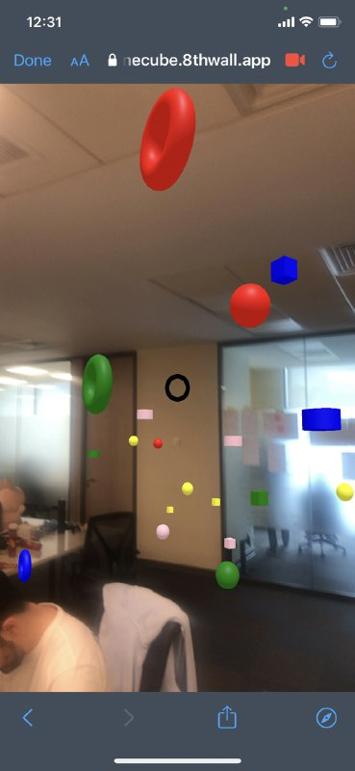

**Technology:** C#, ASP.Net Core, EntityFramework Core, Python socket.io, PostgreSQL

**Description:** The project is a web AR (augmented reality) app and it is in the testing process. This is a game where there are 2 players: solver and explorer. On the solver's device there is a cube displayed, and on one of the sides of the cube (implemented randomly) there is a hint about the figure that the explorer on his device has to find. The hint includes figure type (whether it is circle or box), figure color, and count (how many figures have to be found to get to the next stage). The goal of the project is to provide an active game for the people that want to play together and communicate in an intense situation where each player depends on each other.

**Responsibilities:** Develop the back-end side of the app and I deal with the deployment of the project. Also at the beginning of each game there is always a different random story given to the players. I also implement this story generator with the help of GPT-3 (OpenAI’s autoregressive language model that uses deep learning to produce human-like text)

### Volunteer Assignment Platform

**Role:** Backend developer

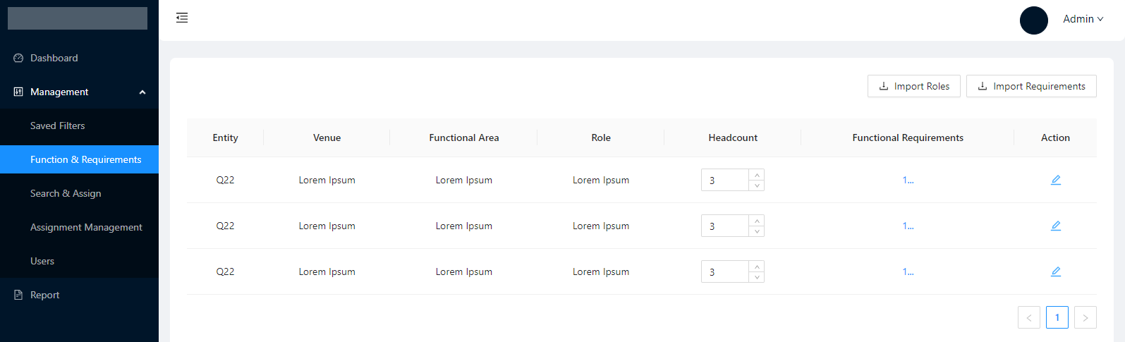

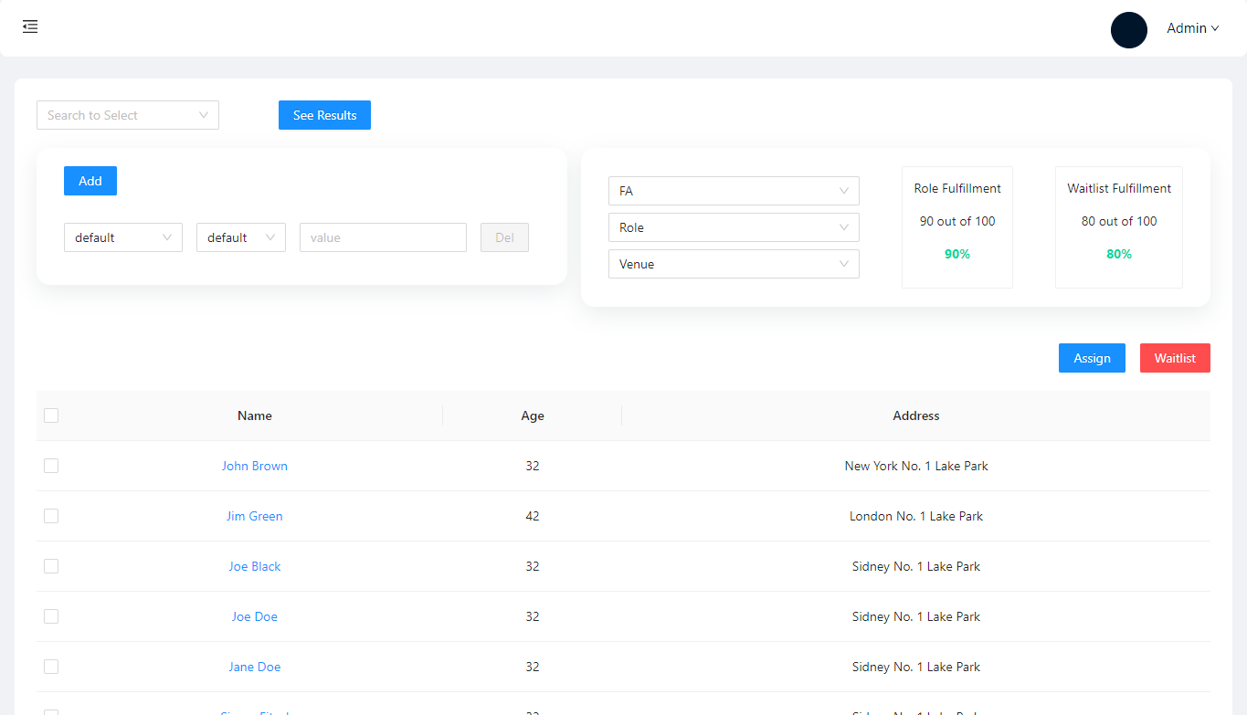

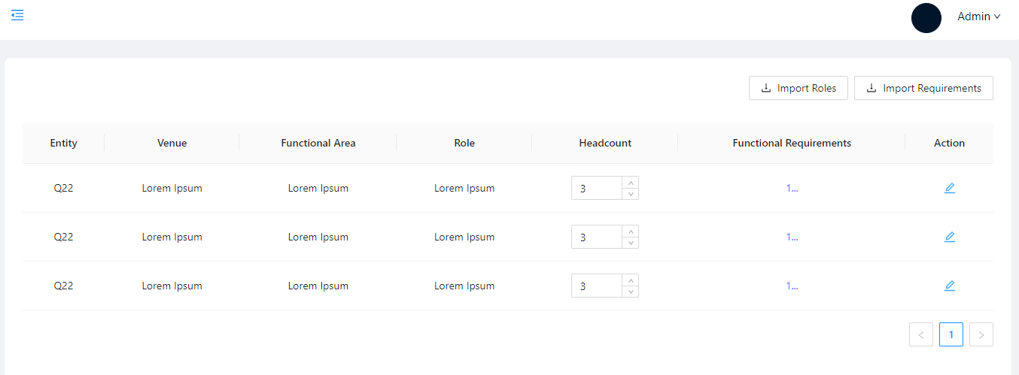

**Technology:** C#, ASP.NET Core, Entity Framework Core, React, Python FastAPI, PostgreSQL

**Description:** The Aramis VAP (volunteer assignment platform) is a web-based solution for processing all assignment procedures in an effective and quick as possible way. This gives the operational team’s great opportunity to assess a huge amount of volunteers while reducing the amount of time and resources required for completing this task. The platform is designed to provide a centralized and user-friendly interface to assign functions and/or roles. By applying the best industry practices there will be no time wasted for completing the necessary workflow. Aramis platform provides a solution for managing all operational aspects during the volunteer assignment cycle.   
  
**Responsibilities:** I built APIs that mainly deal with the assignment processes. There is integration with Rosterfy (Leading Staff and Volunteer Scheduling Software) where data exchange through AWS SNS occurs. I also developed the needed endpoints for successful integration. In addition, I built an independent service that mainly focuses on authorization. Finally, the backend of the platform is split into microservices which are deployed in Azure Kubernetes cluster.

### SmarterHotels

**Role:** Full-stack developer

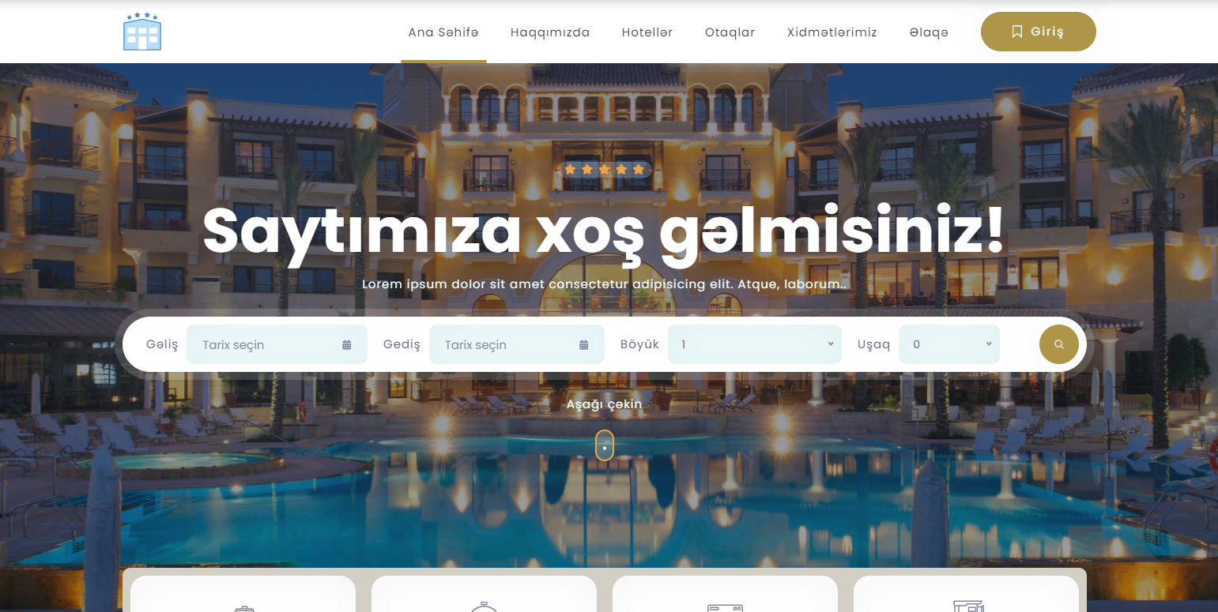

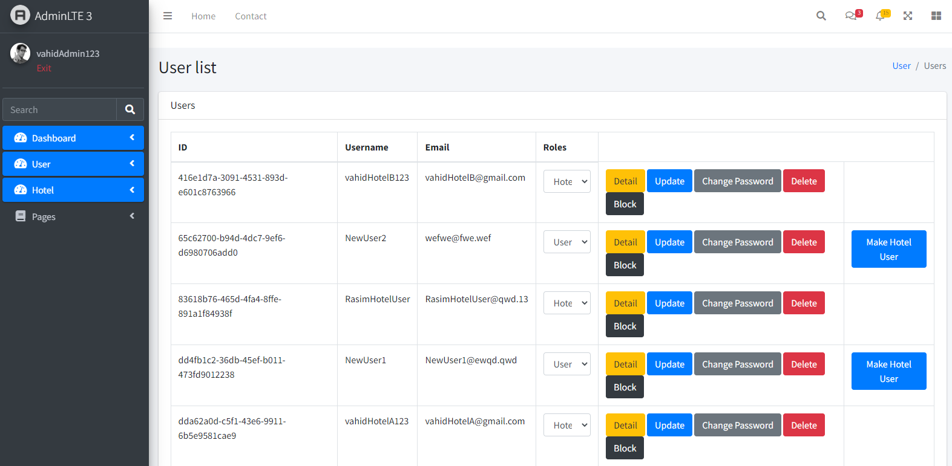

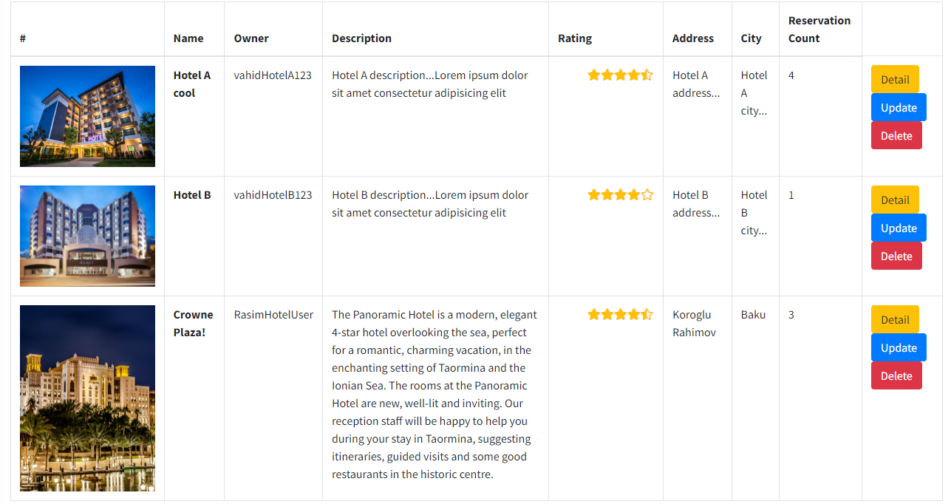

**Technology:** C#, ASP.NET Core, Entity Framework Core, HTML, CSS, AJAX, JavaScript, MSSQL  
 **Description:** The app is a hotel management system. Tech stack is HTML, CSS, bootstrap, Javascript for the front-end, asp.net core MVC for the back-end side, database MSSQL. The goal was to create a system for hotel owners so that they can share their hotel pictures etc, and also to make it easy for customers to find the desirable hotel.  
  
**Responsibilities:** built the entire back-end side of the app using asp.net core mvc (basic crud operations for the main website as well as for the admin page). Participating in the front-end side, writing code for ajax requests.

### 

### Prosong

**Role:** Full-stack developer

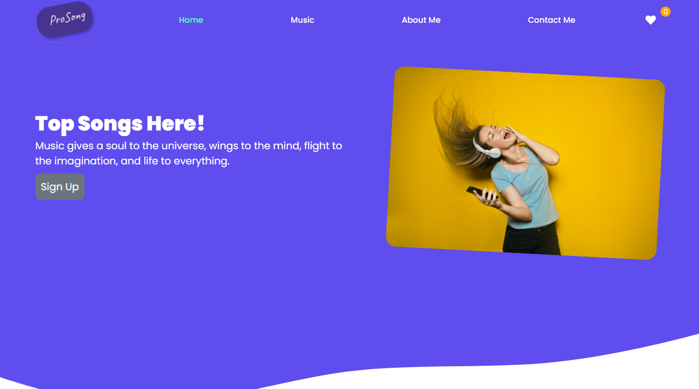

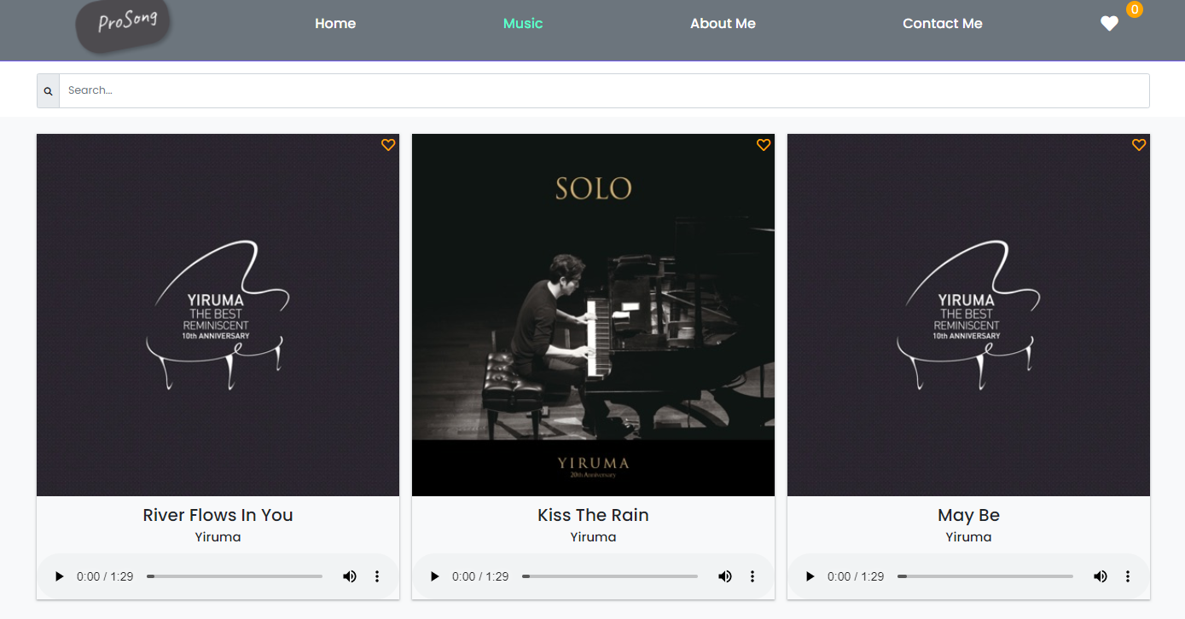

**Technology:** HTML, CSS, JavaScript, BootStrap, Shazam API **Description:** The goal was to build a simple static portfolio-like website as well as a platform for people to find their favorite music. Users can also search for the song and the song will be brought from shazams database. Users are able to listen, search and download the songs that they want.

**Responsibilities:** Build the entire site, its layout with Shazam API integration.

### Other Projects

Other projects are under NDA.

|  |  |
| --- | --- |
| Github Link | <https://github.com/Vahid-code?tab=repositories> |

|  |  |
| --- | --- |
| Reference | References are available upon request |